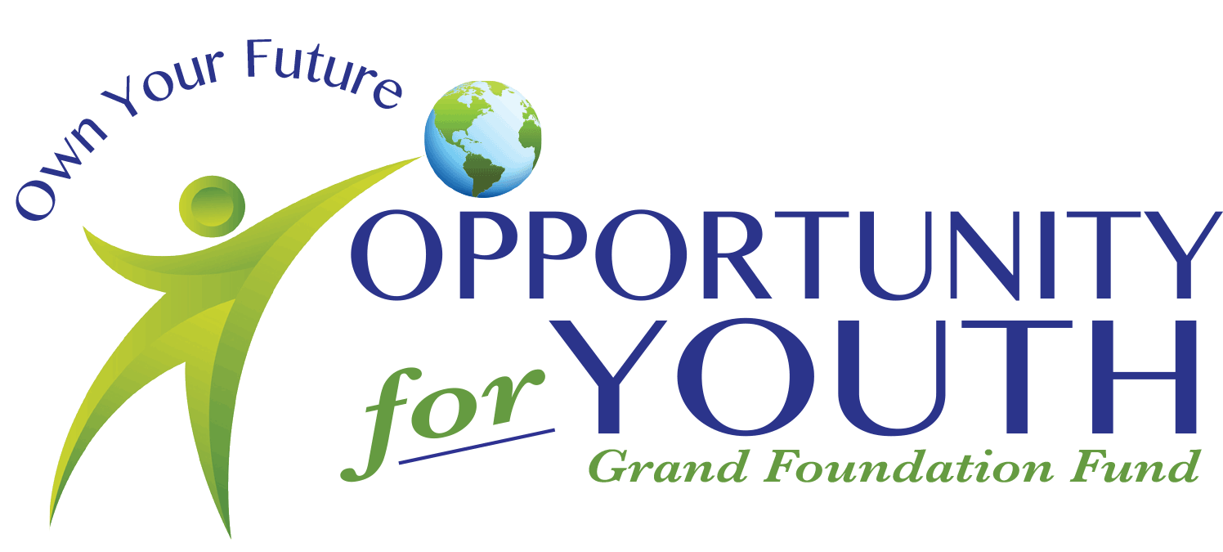

Opportunity for Youth Fund, a Fund of the Grand Foundation
Scholarship Application: Class of 2026

The Opportunity for Youth Scholarship is a $4,000 scholarship distributed in $1,000 payments over each of 4 academic years provided the student maintains the required academic progress. Please complete the required information and attached application for scholarship review.

Applicant Name: ______________________________________________________

Mailing Address: ______________________________________________________

Home Phone: ____________________ Cell Phone: __________________________

Birth Date: ______________________ Social Security #: ___________________

High School Name and Graduation Date: _________________________________

Grade Point Average: _____________ Rank ___/___ (Include Transcript)

Application Process:
1. Complete this Application Form.
2. Write an essay on a separate sheet(s) of paper making sure your name appears somewhere on the essay. Please explain in your essay the following:
a) The challenges you have faced up to this point in your life and what you did to attempt to overcome those challenges
b) What your college and life goals are
c) What are the values you believe in for your future

3. On a separate sheet of paper, please answer the following questions. (Typed answers preferred, although handwritten responses are acceptable.) Include your name on this sheet.
a) Please explain the need of this scholarship and or any extenuating circumstances that would enable you to be eligible for funding. (Without support will the youth be able to still attend college/trade school?) This is a needs-based scholarship.
b) Please describe your college and career goals and plans
c) Please list any other sources of funding you applied to and/or have received funding from for this activity. (i.e. Other scholarships, local or from the attending entity, etc.)
d) List and describe your community service including the estimated total numbers of hours you invested in each activity.
e) List and describe your extracurricular activities both inside and outside of school along with any awards earned.

Opportunity for Youth Fund, a Fund of the Grand Foundation
Scholarship Application: Class of 2026
GRANT APPLICATION (Page 2)

- Please attach individuals and/or family’s tax return for 2024 or 2025.
- Include pages 1 & 2 of your 1040, 1040A or 1040 EZ (page 1).
- If dual households please include tax returns for both parents.
- For dual households, tax return can be sent directly to the Grand Foundation and are considered confidential.

DUE: Wednesday April 1, 2026 (by 4:00 pm to the Grand Foundation office. If mailing, please allow extra time to ensure it is received by the 1st).

Send your applications to: Grand Foundation P.O. Box 1342 Winter Park, CO 80482
Questions? Contact Scholarship Committee: 970-887-3111 Email: megan@grandfoundation.com

The Grand Foundation seeks to improve the quality of life in Grand County by proactively addressing current and future needs in the areas of Health & Human Services, Environment, Education, Amateur Sports, and Arts & Culture.

